**Solutions to Exercises** Expand CIDR Ranges

172.16.0.0/12

nid bits = 12

host id bits = 32-12 = 20

IP: 10101100.00010000.00000000.00000000

SM: 11111111.11110000.00000000.00000000

255.240.0.0

IP: 10101100.0001xxxx.xxxxxxxx.xxxxxxxx

10101100.00010000.00000000.00000000 => 172.16.0.0

10101100.00011111.11111111.11111111 => 172.31.255.255

192.168.0.0/16

SM: 255.255.0.0

IP: 192.168.0.0 - 192.168.255.255

10.0.0.0/8

SM: 255.0.0.0

IP 10.0.0.0 - 10.255.255.255

10.100.192.0/20

nid = 20

hid = 32-20 = 12

IP: 00001010.01100100.11000000.00000000

SM: 11111111.11111111.11110000.00000000

255.255.240.0

IP: 00001010.01100100.1100xxxx.xxxxxxxx

00001010.01100100.11000000.00000000 = 10.100.192.0

00001010.01100100.11001111.11111111 = 10.100.207.255

10.10.0.0/21

IP: 00001010.00001010.00000000.00000000

SM: 11111111.11111111.11111000.00000000

: 255.255.248.0

IP: 00001010.00001010.00000xxx.xxxxxxxx

: 00001010.00001010.00000000.00000000 => 10.10.0.0

: 00001010.00001010.00000111.11111111 => 10.10.7.255

**Subnet**

* This is subnetwork i.e. it is a part of network
* We need to create a private network with six subnets for the following 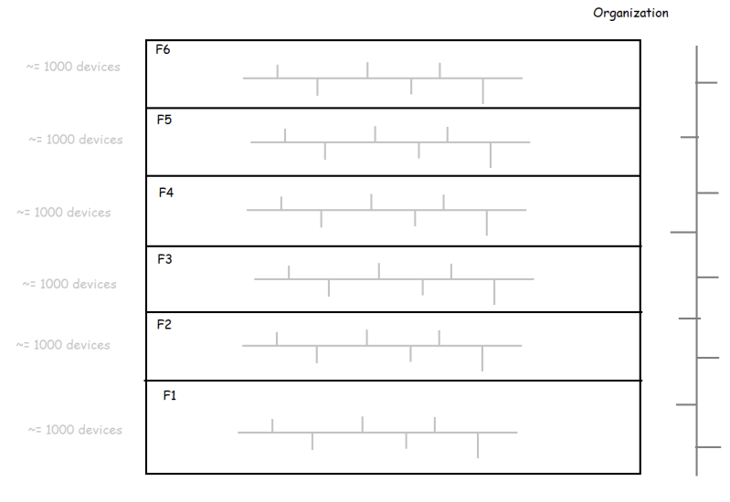
* Private network ranges: When we create any private network it has to be in the following ranges
  + 10.0.0.0/8
  + 172.16.0.0/12
  + 192.168.0.0/16 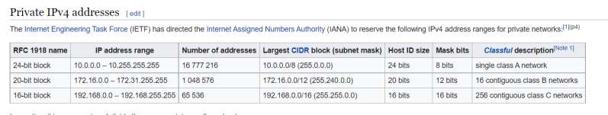
* Total organization devices ~= 6000

2^n - 2 ~= 6000

2^n ~= 6000

n = 13

host bits = 13

network id = 32-13 => 19

So let’s choose 192.168 series

192.168.0.0/19

IP: 11000000.10101000.000xxxxx.xxxxxxxx

SM: 11111111.11111111.11100000.00000000

* So the total organization network cidr 192.168.0.0/19
* Now we need to create subnet cidrs.
* Each subnet requires 1000 devices

2^n ~= 1000

n = 10

host id bits for subnet = 10

network id bits = 22

IP: 11000000.10101000.000xxxxx.xxxxxxxx

SM: 11111111.11111111.11100000.00000000

IP: 11000000.10101000.000xxxxx.xxxxxxxx

subnet:

N-SM: 11111111.11111111.11100000.00000000

S-SM: 11111111.11111111.11111100.00000000

N-IP: 11000000.10101000.000xxxxx.xxxxxxxx

S-IP: 11000000.10101000.000xxxyy.yyyyyyyy

Possible

F1: 11000000.10101000.000000yy.yyyyyyyy => 192.168.0.0/22

F2: 11000000.10101000.000001yy.yyyyyyyy => 192.168.4.0/22

F3: 11000000.10101000.000010yy.yyyyyyyy => 192.168.8.0/22

F4: 11000000.10101000.000011yy.yyyyyyyy => 192.168.12.0/22

F5: 11000000.10101000.000100yy.yyyyyyyy => 192.168.16.0/22

F6: 11000000.10101000.000101yy.yyyyyyyy => 192.168.20.0/22

